**SQL JOIN**

* To combine rows from two or more tables based on a common field between them.
* **INNER JOIN**: Returns all rows when there is at least one match in BOTH tables
* **LEFT JOIN**: Return all rows from the left table, and the matched rows from the right table
* **RIGHT JOIN**: Return all rows from the right table, and the matched rows from the left table
* **FULL JOIN**: Return all rows when there is a match in ONE of the tables

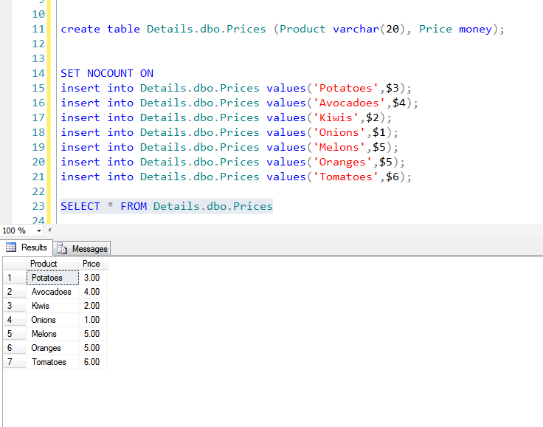

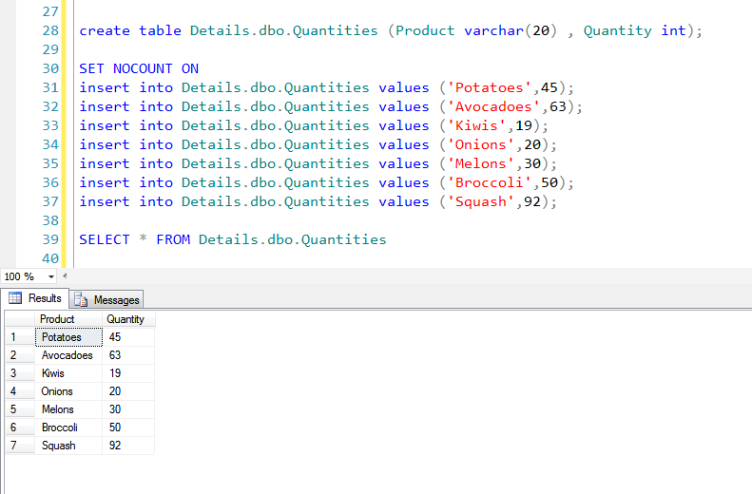

**INNER JOIN**

* Focuses on the commonality between two tables.
* There must be at least some matching data between two (or more) tables that are being compared
* Searches tables for matching or overlapping data.
* Returns the information into one new table.

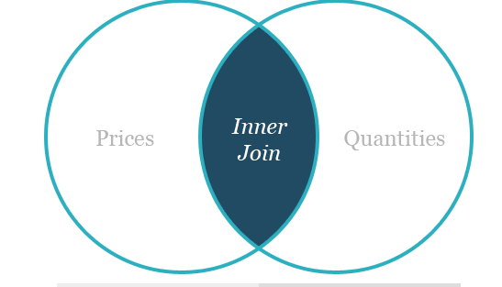

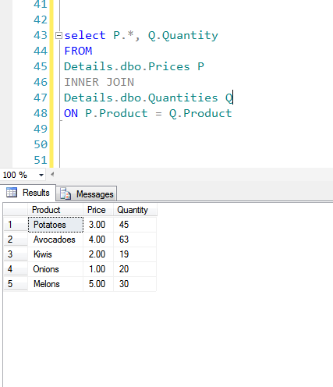

* Two tables are Product prices and quantities.
* Common information is product name, so that is the logical column to join the tables ***on***.
* There are some products that are common in the two tables; others are unique to one of the tables and don't have a match in the other table.

An inner join on *Products* returns information about only those products that are common in both tables.

**OUTER JOIN**

* Returns a set of records (or rows) that include what an inner join would return but also includes other rows for which no corresponding match is found in the other table.
* There are three types of outer joins:
* Left Outer Join (or Left Join)
* Right Outer Join (or Right Join)
* Full Outer Join (or Full Join)

### Left Outer Join

* Returns all the data in Table 1 and all the shared data.

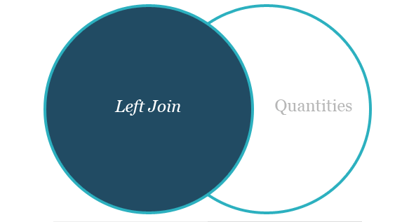

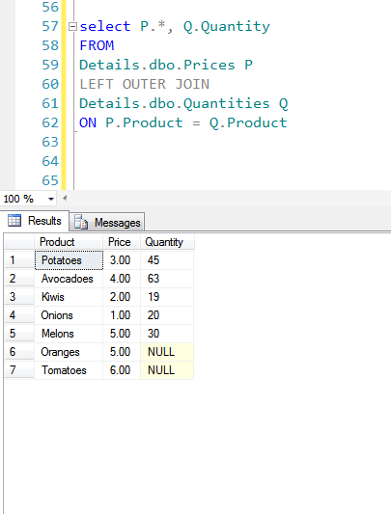

* There are two products — oranges and tomatoes — on the 'left' (*Prices* table) that do not have a corresponding entry on the 'right' (Quantities table).
* In a left join, these rows are included in the result set with a NULL in the Quantity column.
* The other rows in the result are the same as the inner join.

### Right Outer Join

* A right outer join returns Table 2's data and all the shared data.

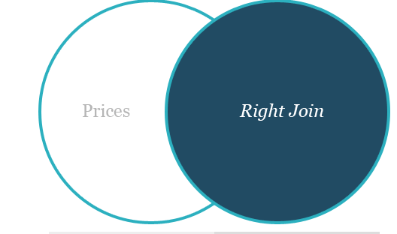

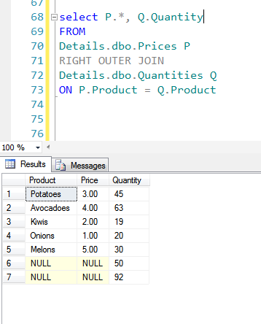

* Similar to the left join example, the output of a right outer join includes all rows of the inner join and two rows — broccoli and squash — from the 'right' (*Quantities* table) that do not have matching entries on the left.

### Full Outer Join

* Combines and returns *all* data from two or more tables, regardless of whether there is shared information.
* Where matching data is missing, nulls will be produced.



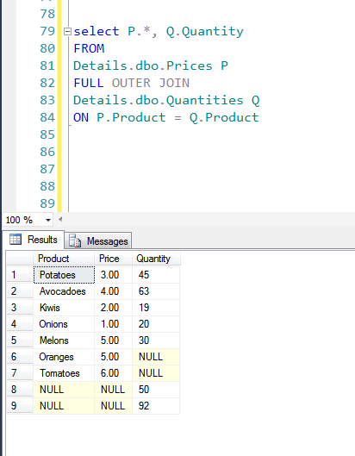

The FULL OUTER JOIN keyword returns all the rows from the left table (Customers), and all the rows from the right table (Orders).

## ****CROSS JOIN****

* **Selects the all the rows from the first table and all the rows from second table and shows as Cartesian product, with all possibilities.**

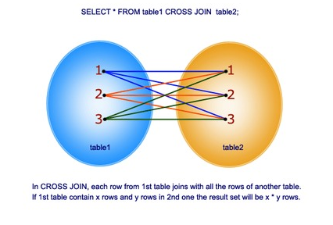

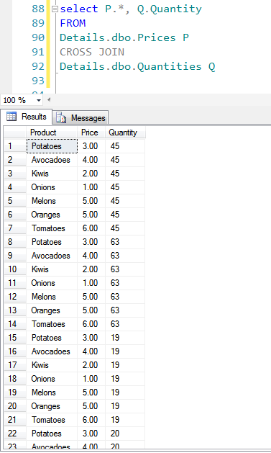

Other Joins

* 1. Loop Join
  2. Merge Join
  3. Hash Join